# Microsoft Access 2010

# Lab 3

In this lab you will learn how to add relationships between tables.

**Creating Relationships between Tables**

When you first create a table, it is not related to any other table. To create a relationship, you start by opening the Relationships window and add the tables or queries you want to relate and then you define the relationship(s).

**To display the Relationships window**

In the Database window, choose **Relationships** from the **Database Tools** menu (or click the **Relationships** button on the toolbar).



If you have viewed or edited relationships before, the Relationships window appears as you last saved it. If you are editing relationships for the first time in this database, the window is empty and Microsoft Access displays the Show Table dialog box.

**To add tables or queries to the Relationships window**

1. If the Show Table dialog box is not automatically displayed, choose **Show Table** from the **Relationships** menu (or click the **Show Table** button).



2. Select the table or query you want to create a relationship for, and then choose the **Add** button. To select more than one table or query at a time, hold down the **CTRL** key and click each you want to add. To select all or a block of tables and queries, click the first table or query, then hold down the **SHIFT** key and click the last one.

**To create a relationship**

1. Drag the field(s) that you want to relate from the field list of a table or query to the matching field in another table or query. The field you drag belongs to the **primary table**; the matching field where you drop it belongs to the **related table**.

1. Microsoft Access displays the Relationships dialog box. Check the field names displayed in the two columns and edit them if necessary.
2. Make sure that the fields you want are the ones appearing in the relationship **Edit Relationships** pop-up window.
3. Make sure that the relationship-type listed is the right one – **one-to-one** or **one-to-many**.
4. Check “Enforce Referential Integrity” checkbox.
5. Choose **OK**.

Microsoft Access creates the relationship and displays a line between matching fields in the two tables. The relationship remains in your database until you delete it.

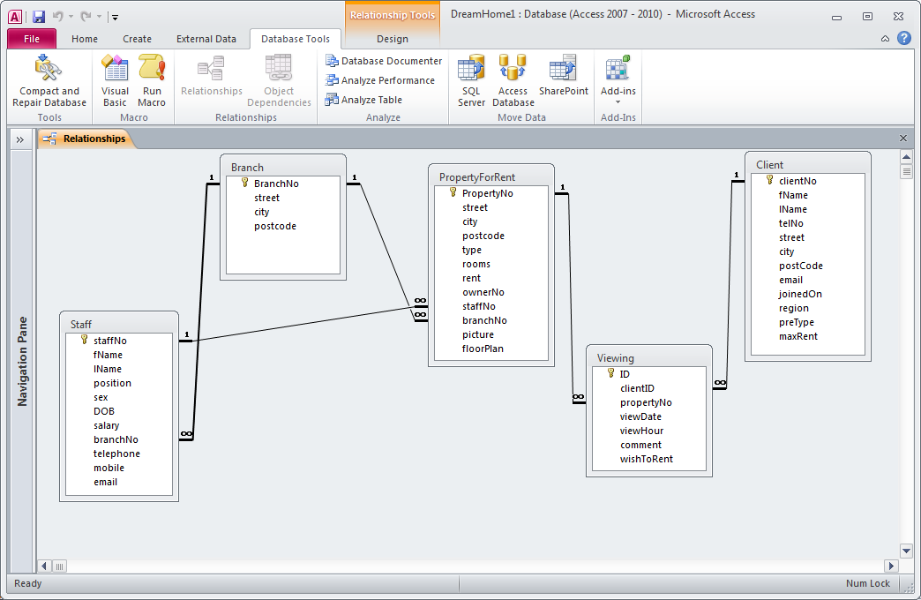

**Figure P3-1 Relationships window with al relationships represented**

***Activity P3-1***

Create relationships between your Branch, Staff, Client, PropertyForRent and Viewing tables using the Relationship window.