# Microsoft Access 2010

# Lab 2

# Creating and Editing Tables

In this lab we will look at the basics of creating tables and fields in Microsoft Access.

**Create a Table**

Microsoft Access provides three ways to create a blank (empty) table:

* Create a blank table in Datasheet view and add the fields directly.
* Use Design view to specify all of your table details from scratch.
* Enter data directly into a blank datasheet. When you save the new datasheet, Microsoft Access will analyse your data and automatically assign the appropriate data type and format for each field.

Regardless of which method you use to create a table, you can use table Design view at any time to customize your table further, such as adding new fields, setting default values or creating input masks.

In the following sections we will describe in more detail the process of creating a table using a Table Wizard and then how to create a table using design view.

**To create a table using Datasheet view**

1. Start Microsoft Access, and open the database that is to contain the table.
2. In the **Create** window, click the **Table** button. Microsoft Access displays the New Table , Table1, as shown in Figure P1-3.

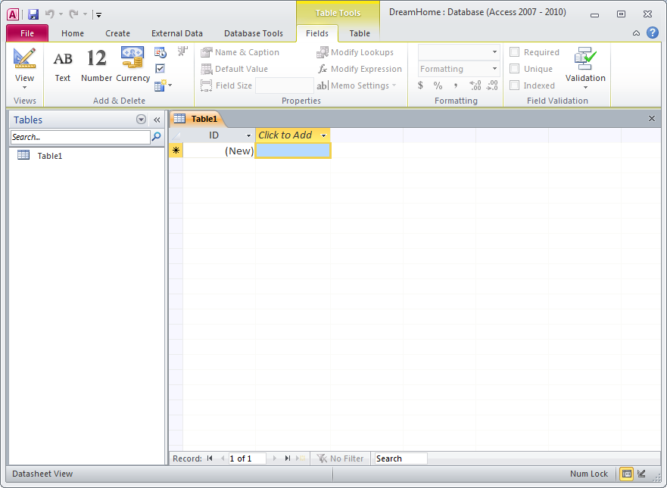

**Figure P2-1: New Table Datasheet view.**

1. Enter data on a row and use **Tab** to navigate to the next column. Access associates names to the columns by default: **Field1**, **Field2**, …

**To create a table using Design view**

1. In the **Create** window, click the **Table** **Design** button. Microsoft Access displays the New Table, Table1, as shown in Figure P2-2.

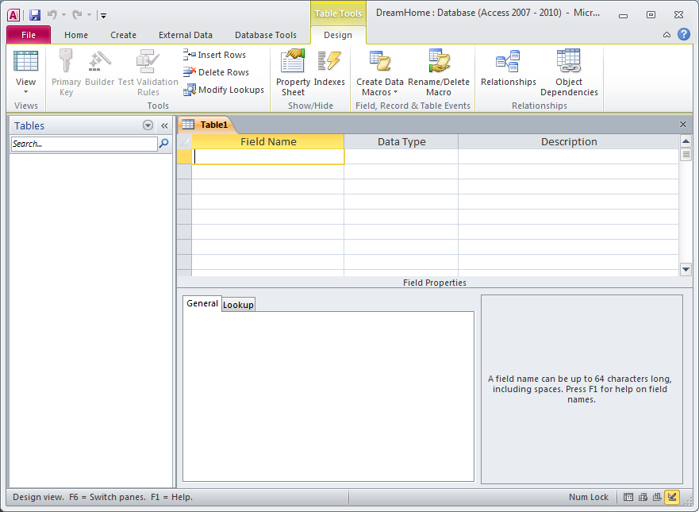

**Figure P2-2: Table Design view.**

**Plan Fields and Data Types**

The **Field Name** identifies the data stored in a field. A field name can contain up to 64 characters, including spaces. The **Data Type** tells Microsoft Access what kind of data goes in the field, such as text, numbers, dates or currency.

A brief description of the most commonly used data types is given below:

The **Text** data type is used for words (such as names), for combinations of words and numbers (such as addresses), and for numbers that are not used in mathematical calculations (such as telephone numbers).

The **AutoNumber** data type stores sequential numbers created by Microsoft Access.

The **Date/Time** data type is used for dates and times.

The **Number** data type is used for numbers that can be used in mathematical calculations, and also for fields that are related to other Number fields or to AutoNumber fields.

The **Currency** data type is used for currency values such as francs, dollars, or yen.

The **Yes/No** data type is used for yes or no, true or false values.

The **Memo** data type is used to store long textual descriptions up to a maximum size of 64,000 characters. Memo fields cannot be indexed.

**More Information** For details about data types, click in the **Data Type** column and press F1.

**Add Fields to the Table**

**To add a field**

1. Type the name of the field to be added in the first empty box under **Field Name**.
2. Press **TAB** to move to the **Data Type** box. Microsoft Access gives the field a Text data type. However, if the field is not text, you’ll need to select the appropriate data type.
3. To open the list of alternative data types, click the arrow or press ALT+ DOWN ARROW.

4. Press **TAB** to move to the **Description** box. If required, you may enter in a short description for each field to help you remember the purpose of the field.

**Set Field Properties**

Each field in a table has a set of properties. By changing a field’s properties, you can control how Microsoft Access stores, handles, and displays data in a field. For example, you might want your data displayed in a particular format – numbers in scientific notation, perhaps, or dates with the month’s name abbreviated. The Format property controls how data is displayed in datasheets, forms, and reports.

**To set a field property**

1. Click any box in the row that defines the field to be set.

2. Click the box of the required property, and then set or select the appropriate property setting.

**To delete a property setting**

Select the setting for the property of the field, and then press the **Delete** key

**More information** For more information about an individual field property, click the property and press F1.

**To set a primary key for a table**

Open the table in Design View and select the appropriate row(s) that form the primary key for the table. Then select the **Primary Key** button on the toolbar.



A key icon will appear in the column to the left-hand side of the field or fields selected to be the primary key. You can also set a primary key by selecting the **Edit** menu and then choosing **Primary Key**.

**To save a table**

1. From the **File** menu, choose **Save** (or click the Save button on the toolbar). 

1. If you are saving the table for the first time, type a name for the table and choose **OK**.

#### To modify the design of an object

1. In the **Navigation pane**, click the button for the type of object (e.g. Tables, Forms) that you want to modify.
2. In the list that is displayed, select the object you want to modify.

Choose the **Design** view from the **View** icon. Microsoft Access opens a window for the object and displays it in Design view.

***Activity P2-1***

In this practical you will create five tables for the *DreamHome* database using Design view. The tables are Branch to hold branch details, Client to hold clients, PropertyForRent to hold the details of the properties for rent, Staff to hold staff details, and Viewing to hold the details of property viewings by clients.

The tables are described in the screenshots at the end of this document.

**Add and Save Records**

Each table in your database has two views: Design view and Datasheet view. You add records to the Datasheet view.

**To switch to Datasheet view**

From the **View** menu, choose **Datasheet** or click on the Datasheet button. The 

arrow to the right of the button lists the alternative views of the table.

**To add a record of data**

Type in the data values and press TAB to the next field.

**To save a record of data**

Once you have entered all of the required records, press TAB to move to the first empty field below these records.

You do not require to do anything else to save your data. When you leave a record, either by moving to another record or by closing a table, Microsoft access automatically saves the data.

**Edit Records and Close a Table**

**To edit records**

There are various ways to edit records. For example:

To move to the next or the previous field, press **TAB** or **SHIFT+TAB**, respectively.

To select or deselect the current field, press **F2**.

To undo changes to the current field or record, press **ESC**.

To replace the value in a field with the value of the same field in the previous record, press **CTRL+’**.

##### To close a table

From the **File** menu**,** choose **Close**.

***Activity P2-2***

Add about 2 records into your Client table.

Reopen your tables and practise editing your records. Finally, save and close your table and exit from the *DreamHome* database.

